Section 1: Calculating DLS using PCS Pro Software (1st XI 50 Over Games and T20 Games)

Please note that the version of DLS that we will be using in 1st & 2nd XI 50 over games is the Duckworth Lewis Stern Professional 2022 (Version 5).

Par Score: This is the value which is displayed. The par score displayed is also the value for the end of the over in progress. i.e. after completing 10 overs, the par score for 10.6 should be displayed. If there is an interruption during that over, the display should be immediately changed e.g. if the players leave the field after 10.3 overs, the display should be changed to show the par score for 10.3 (not 10.6)
This is the score that is needed to draw the match, and it is also a good indicator of how close the game is.
Target Score: This is (Par Score +1) and needs to be achieved for the side batting second to win the game.
Print the par score table after first innings (without interruptions)
Go to Scoring>Revised Overs/Target/DLS
Select from the drop-down menu “Professional (2022, v5).
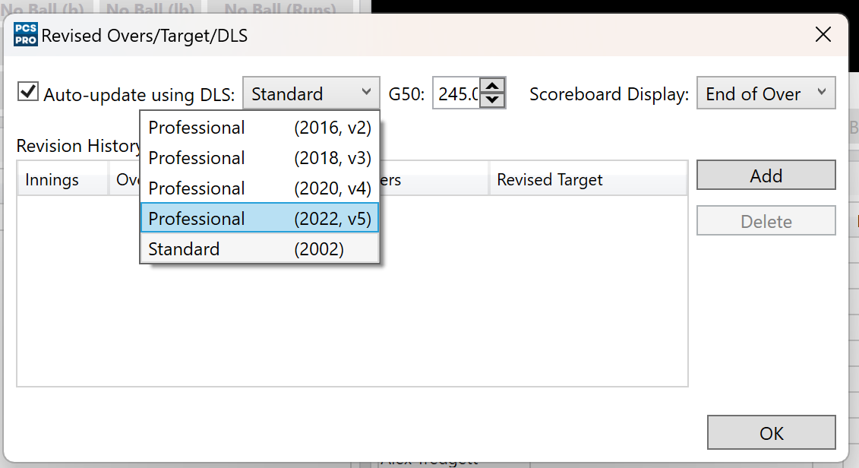
Then click “DLS Par Table”
When the table is generated click the “print” button and hand the sheets to the umpires.
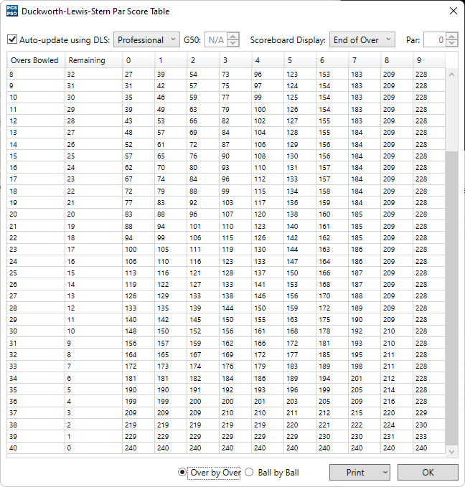
Interruption(s) during the first innings

Go to Scoring>Revised Overs/Target/DLS

Select Add.
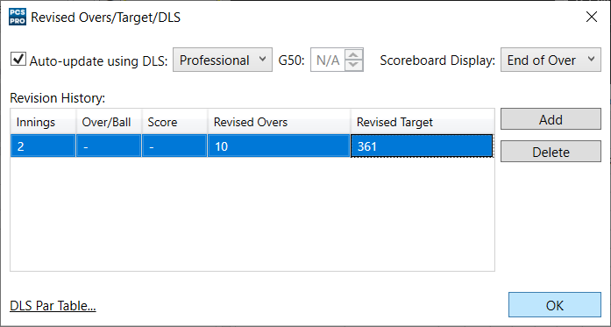

Double left-click on Revised Overs and insert the reduced number.

Press Ok.

The change will show on the Scoreboard and in the Match Notes.
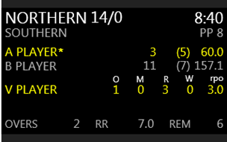
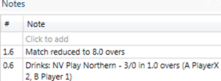
Continue Scoring.

Interruption(s) during the first innings with a premature termination of the first innings.
Repeat the process above up to the point of Revised Overs.
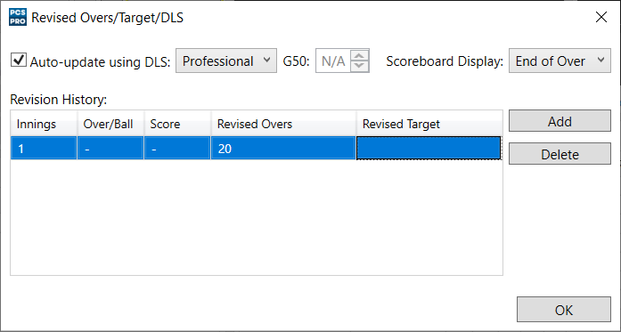

In this situation the first innings has been washed out, so enter the number of overs already played and click Ok. In this instance the innings has been reduced from 10 to 5 overs.

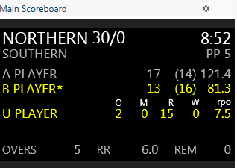
The overs remaining now show as 0.

Select Play State in the Play Control window and then End of Innings.

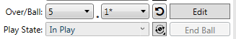
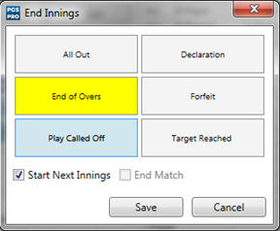
Select End of Overs making sure you also tick the Start Next Innings box before selecting Save.

The change will be shown on the Summary Score window as well as the Scoreboard.
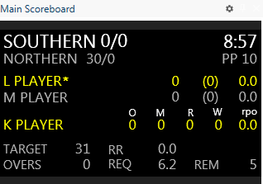

Interruption between innings

Between the innings please follow the same steps as the first example. In this example Northern have faced 10 overs and scored 59/2. Because of rain, Southern will only have 7 overs.
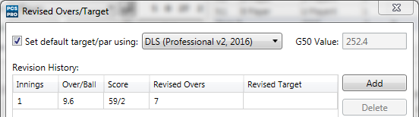
Once the change to Remaining Overs has been made start the next innings.
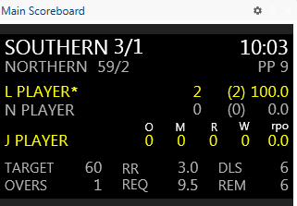

As you can see above the changes are reflected on the Scoreboard as well as the Score Summary window.

Interruption(s) during the second innings
Follow the same process as the first example.

The Revised target will immediately show on both the Notes, Score Summary window and Scoreboard.
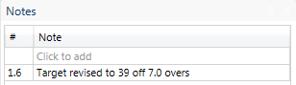
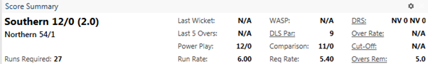
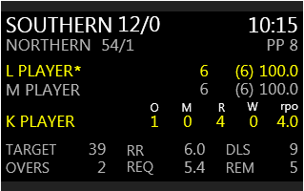

Interruption(s) during the second innings with a premature termination of the second innings

Follow the same process as the second example.
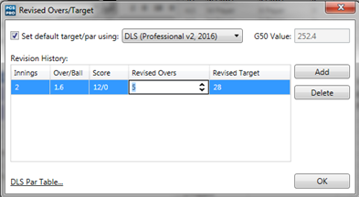

Reduce the number of overs to the amount of overs bowled and press Ok.

Select Play State in the Play Control window and then End of Innings.
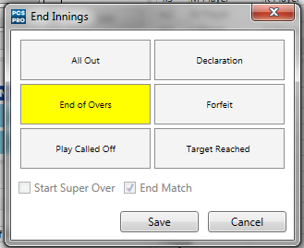

Select End of Overs and Save.
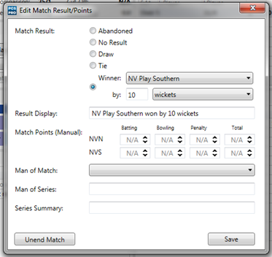

PCS Pro will automatically calculate the winner of the match referring to the DLS/DL score (in this example Southern’ s 31/0 beats the 27 Target score).

Press Save to finalise the result or Unend Match to go back to make changes.

Section 2: Play Cricket Scorer App Duckworth Lewis Calculator Step By Step Guide

We are using the version in the Play Cricket Scorer app – captains and scorers should download the app before the first game of the season from: https://www.play-cricket.com/features-playcricketscorer

When using the PCS Pro scoring software the G50 value you need to use to get the same par score as the DL calculator in the PCS App (245) and use the DLS Professional 2022 (v5).

Then follow the instructions on the Play Cricket website: https://play-cricket.ecb.co.uk/hc/en-us/articles/360000606789-Duckworth-Lewis-The-5-Most-Common-Examples-PCS-Pro-

Step 1

If you have a delay in a 2nd XI Limited overs game that means overs have been lost you will need to make a calculation on the Duckworth Lewis Calculator.

Open up the app and click on tools at the bottom of the screen

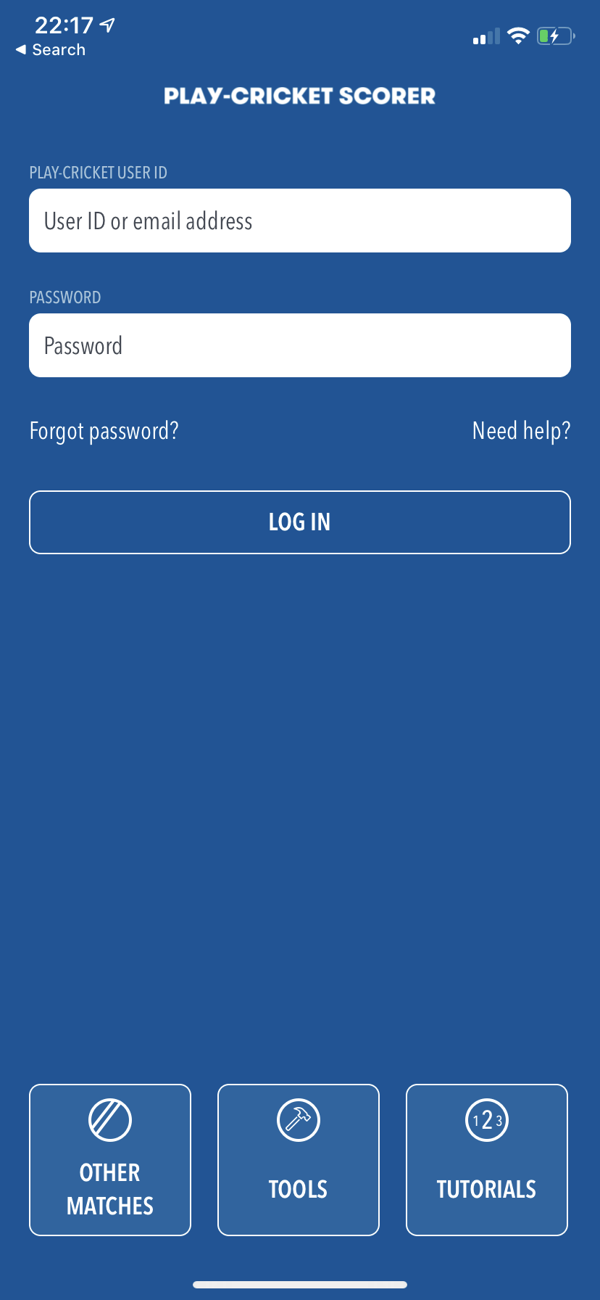

Step 2

Click on D/L Calculator from the pop up menu AND SELECT DUCKWORTH-LEWIS-STERN (V5)

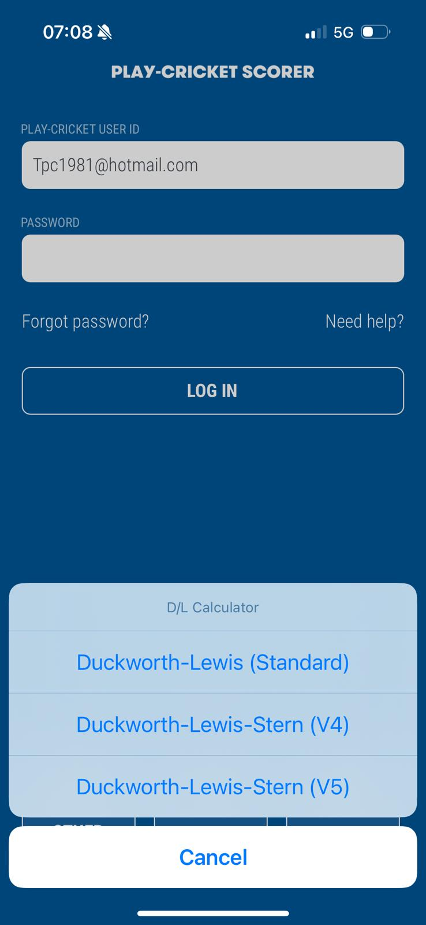

Step 3

Select the Men’s Match (245) and press DONE top right

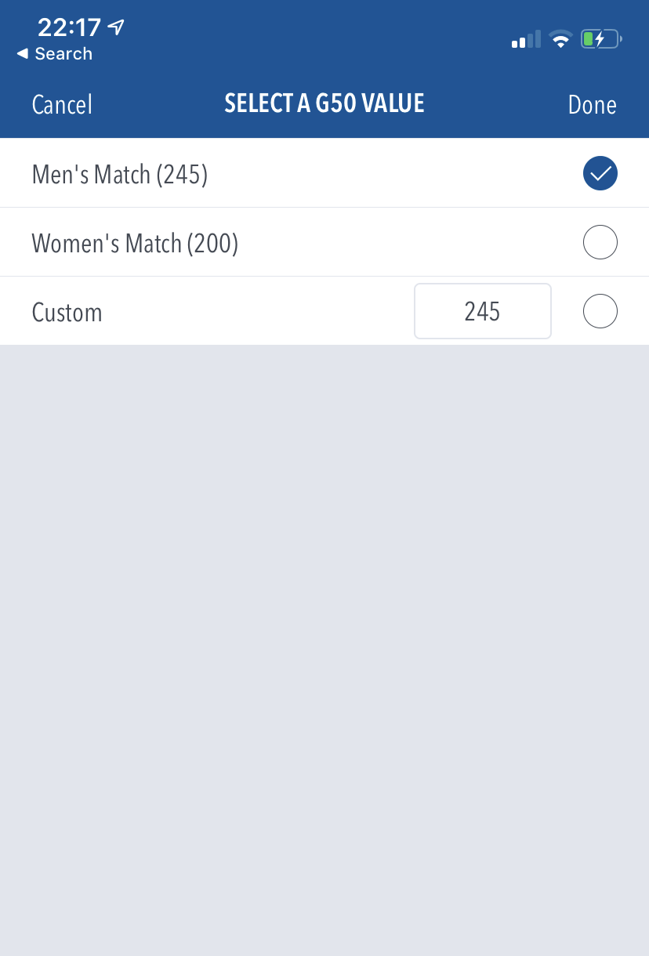

Step 4

Change the overs (top left) 45 for 2nd XI games.

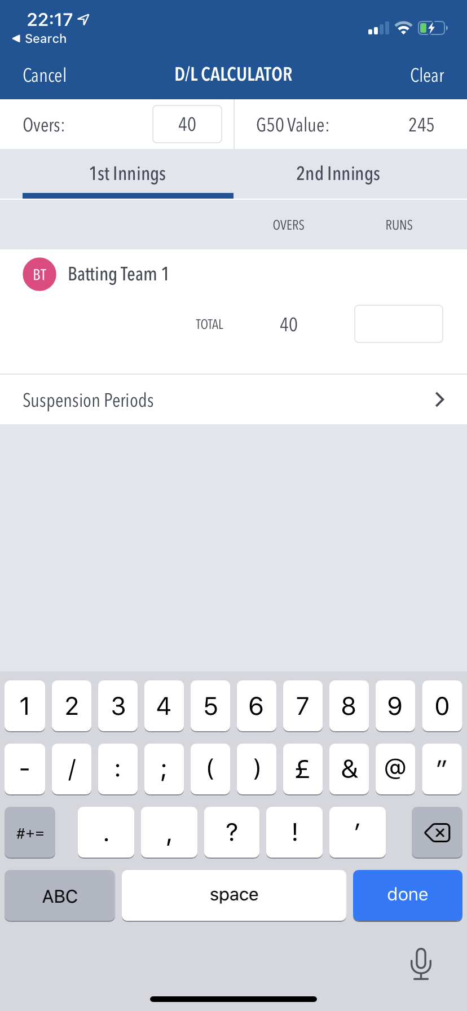

Step 5

Input the score from the 1st innings – if no overs lost from 1st innings just put the score that was reached at the end of the 1st innings.

If there are overs lost click on Suspension Periods and fill in the details.
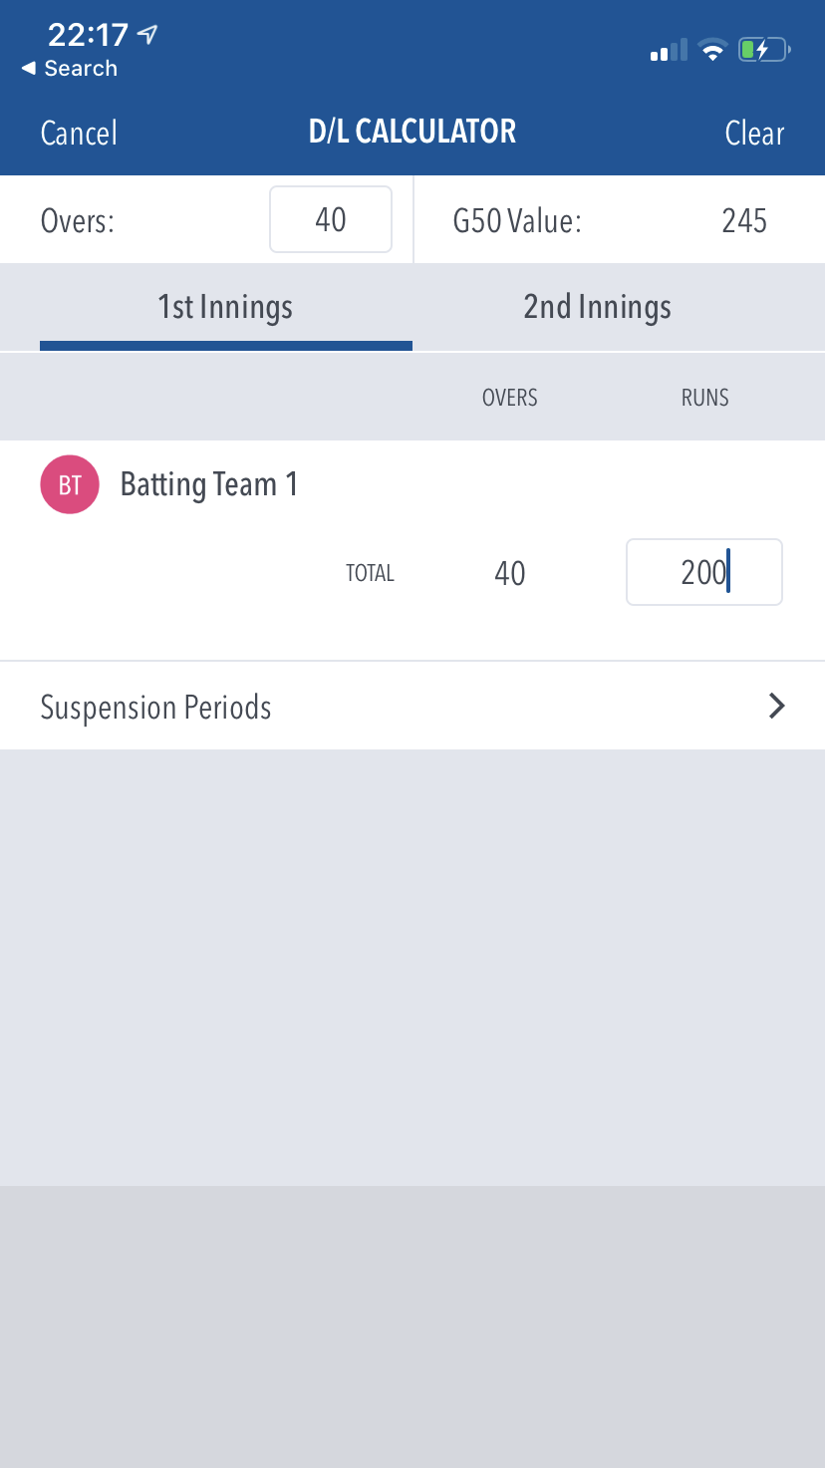

Step 6

Click on 2nd Innings and then click on Suspension Periods

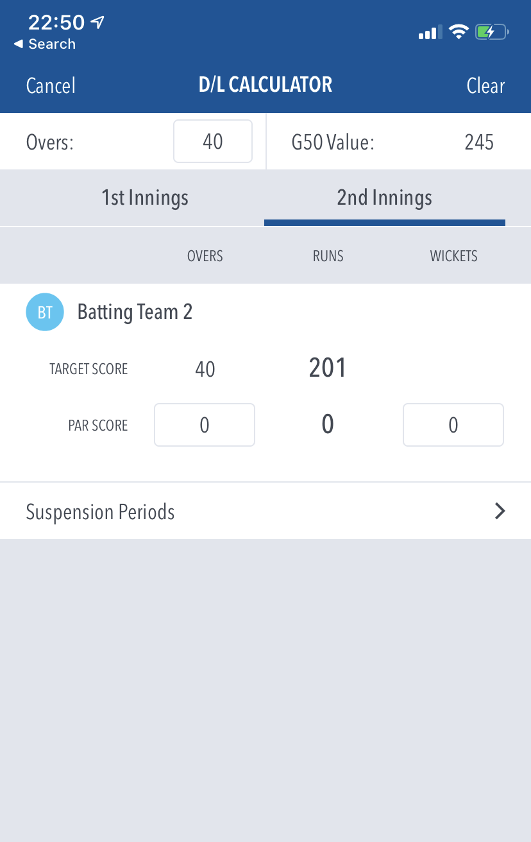

Step 7

Fill in the details of the suspension period – including how many overs are left – (you will have to confirm with umpires how many overs remain) and press done. You can put in 24.3 overs for example and it will create the correct calculation if the stoppage happened mid over.

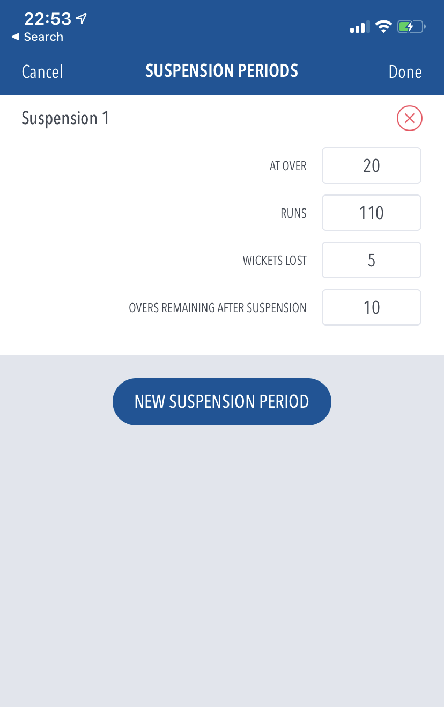

Step 8

The D/L/S score will appear with a target score for if the game now goes through to its full completion.

But also the par score –where the team sits at the current time in the match

so in the example below the team batting 2nd are 110 for 5 off 20 overs when rain comes and they lose 10 overs – a D/L calculation is created and it shows that they need to be at 173 off the 30 overs they will receive to win the game. Also that they are 3 runs behind par at that state in the game (113 for 5 off 20 overs being the D/L par)

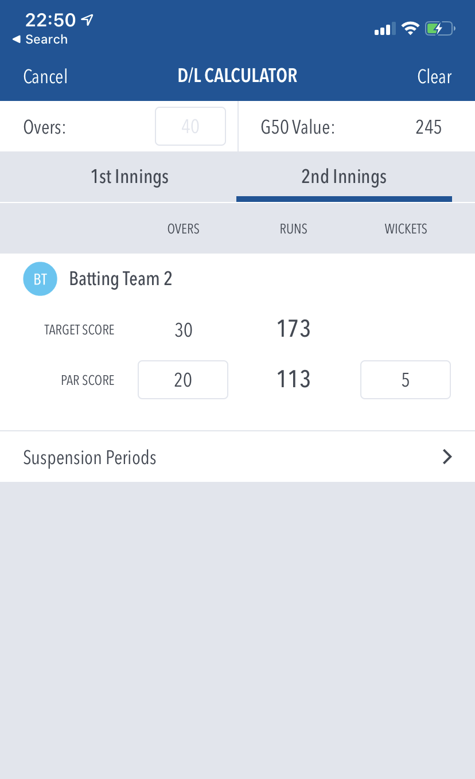

Step 9

If there are further interruptions you can go in and add extra suspension periods – all suspension periods and the overs lost must be accounted for in each suspension period for the correct calculation to be created.

